# Tagged Bible

A tagged Bible is generally a Bible where every word is tagged with a number. In our case these numbers are Strong’s numbers. Variations include multiple words sharing a single number, and a word assigned more than one number and even sometimes, no numbers are assigned.

The initial tagging process uses software to assign numbers to the different words. A single number per word. However, this process usually has an accuracy that can range from 50 to 80 percent. Therefore, manual review and corrections are required. Hence the Bible Tagging Utility where the newly tagged Bible is compared and validated visually against a reference and against a an existing completely tagged Bible.

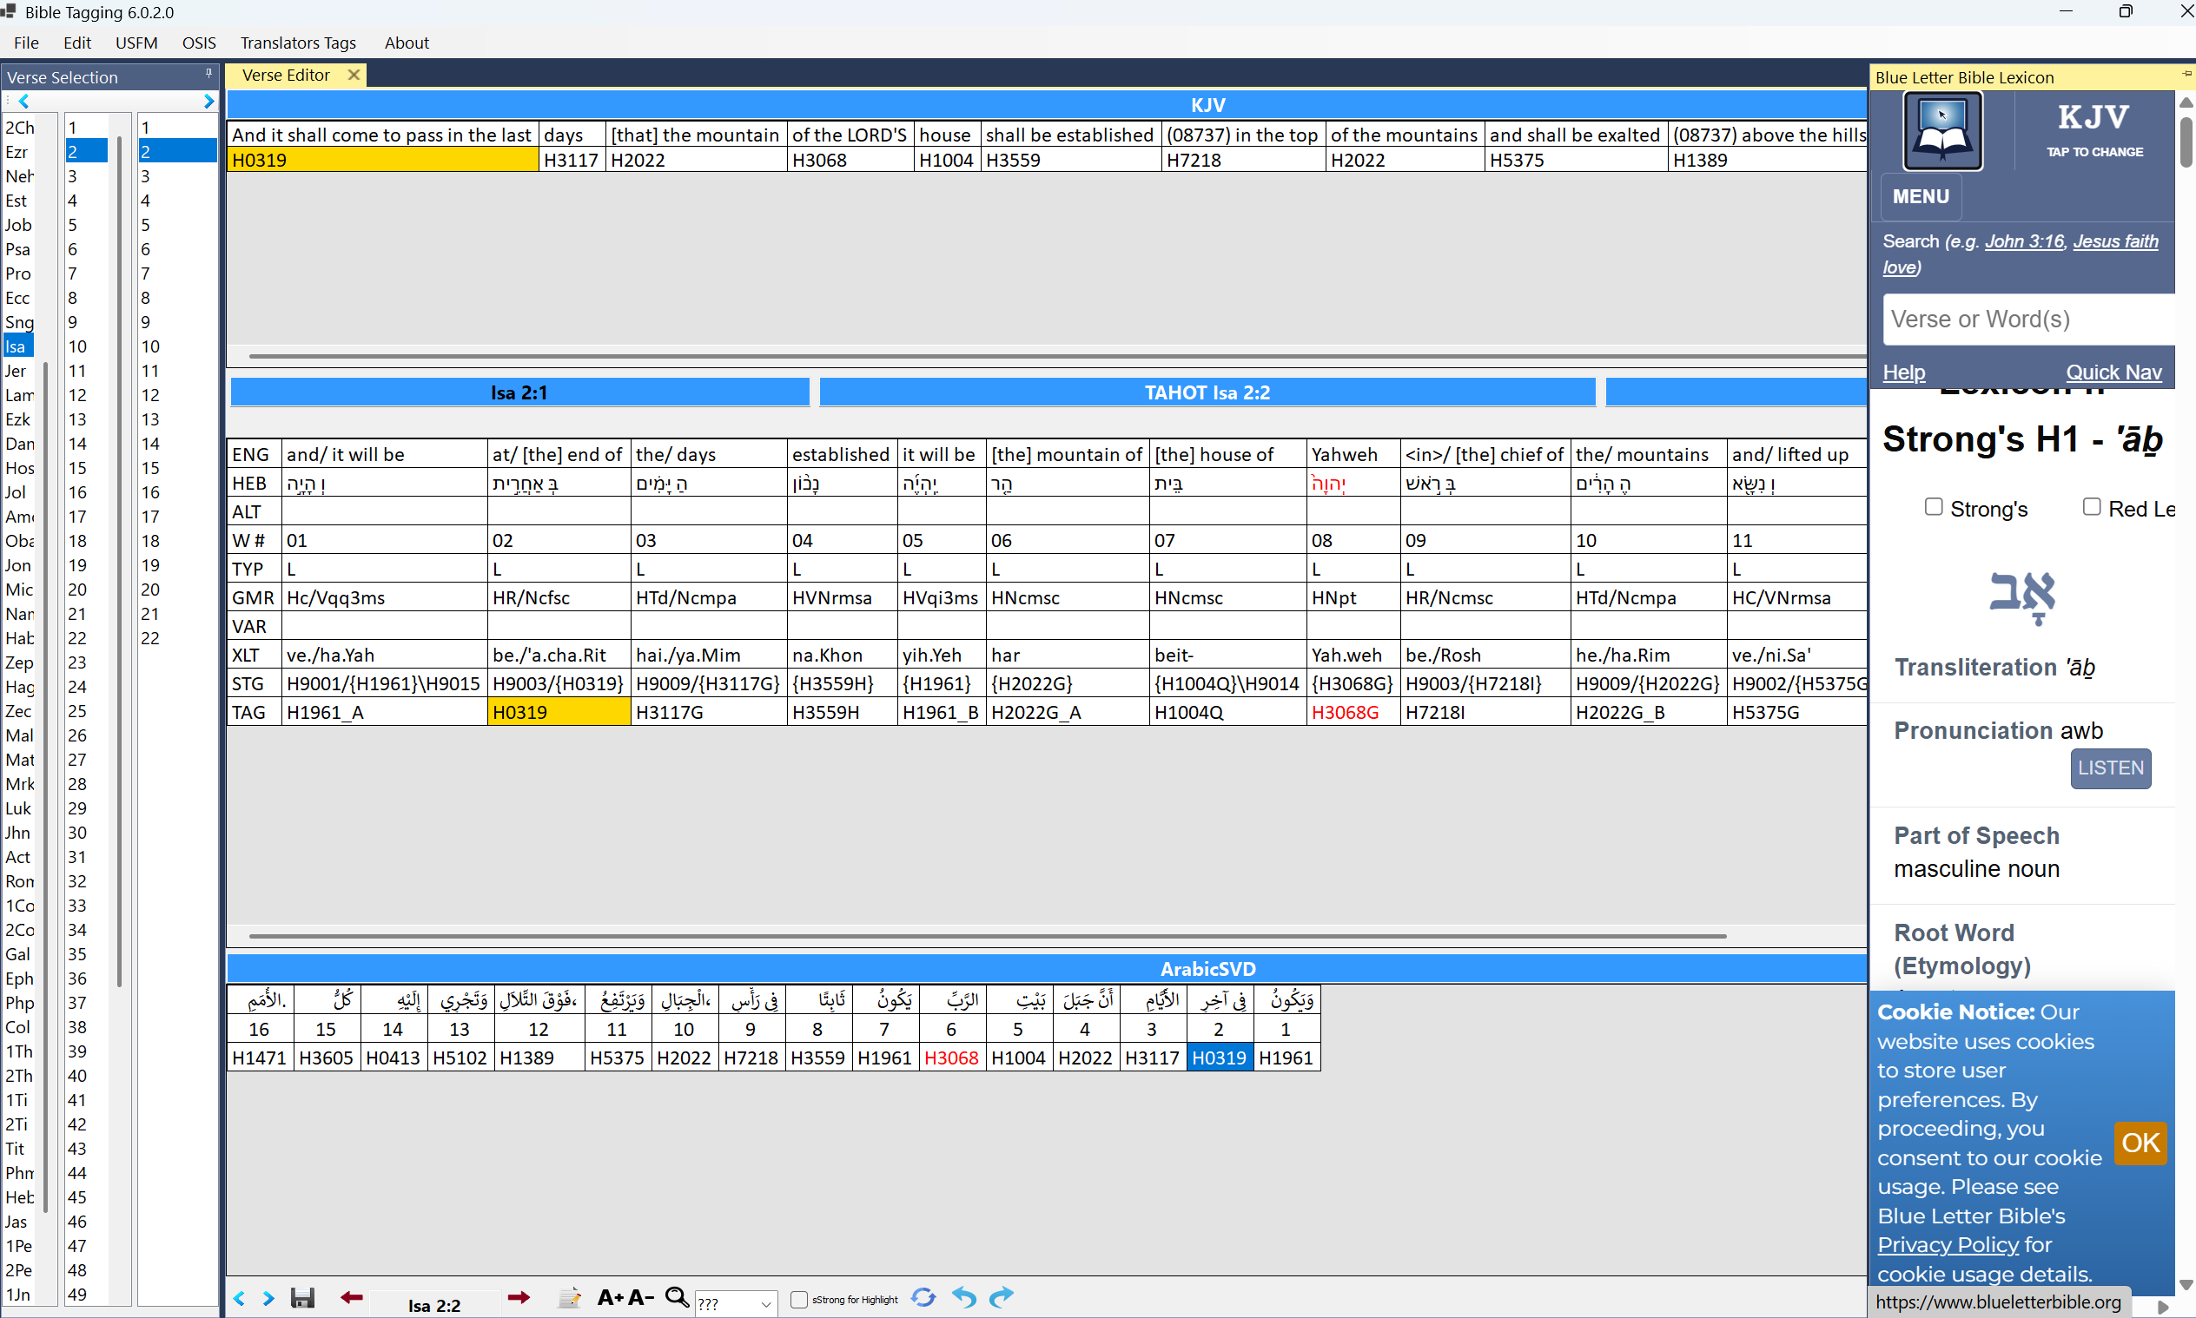

The utility has three main grids. The middle grid shows a verse from the main reference, The top grid shows the same verse from a fully tagged Bible (KJV) , the bottom grid shows the same verse for the Bible to be reviewed. It is imperative that the three grids be visible at the same time to the reviewer to help them asses the need for and carryout the correction. The Winform version allows the vertical resizing of the grids to help the reviewer customize their optimal view. They can also hide the side panes as shown below.

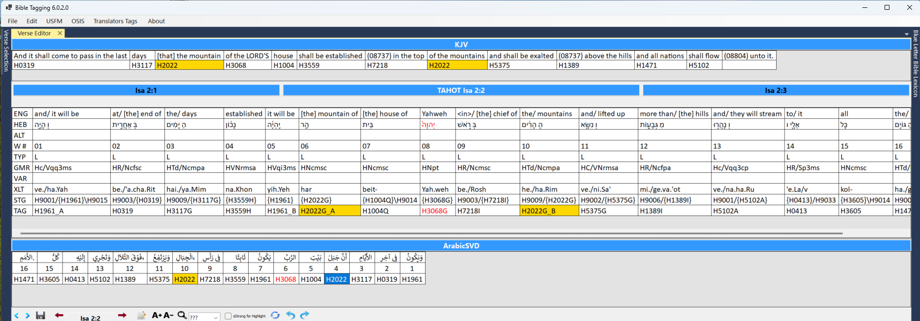

# Functionality

In the following I cover the main points listed in the Readme file at [sabdelmalik/BibleTaggingUtility: Add and/or correct Strong's tags](https://github.com/sabdelmalik/BibleTaggingUtility)

## Drag and Drop behaviour

When a tag is dragged from a reference verse (top two tables) to the target verse (bottom table), the dragged tag will replace the existing tag(s).

However, if the dragged tag is dropped while the Ctrl key is pressed, it is added to the existing tag(s).



Although I understand the motivation behind the bringing up a menu when dropping the tag, I don’t think it is practical. It will slow the process of review. A serious reviewer will use a desktop or a Mac not a tablet and will have access to a control or command key. It will be ok if the app can detect a tablet or phone and bring up the menu in such case only.

## Merging two or more target words

Highlight the target words, then right click on one of them. Click on Merge from the context menu. The merged cells must be adjacent words, otherwise you will not see the Merge menu. to higlight adjacent words, click on the first word, and while the mouse is down, dag it to the right or left as required.



## Splitting a multi word cell

If a target word cell contains more than word, it can be split into seperate words. Click the word cell to select it. Right click the cell and click Split from the contxt menu.



## Swapping two tags

Select the two words that their tags to be swapped. Right click one of them and click the cell and click Swap from the contxt menu. To select two words, click on the first word to select it. While pressing Ctrl, click the second word.



## Deleteing tag value

Right click the tag to delete using the context menu



## Directly editing a tag

Press F2 to Directly edit the tag

